**Recognized Patterns：FakeTimer_variety1**

**The name of the identified app：Fennec F-Droid**

**Corresponding to the name of APP in sample：**

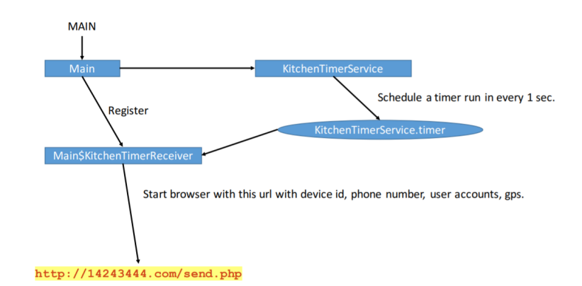

**For function**

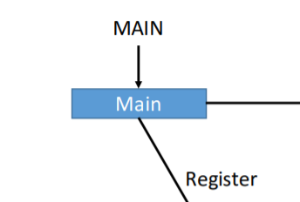

**Mainly used to obtain information about gps, as well as registration**

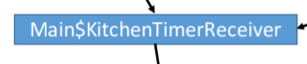

**Corresponding to the key code in sample：**

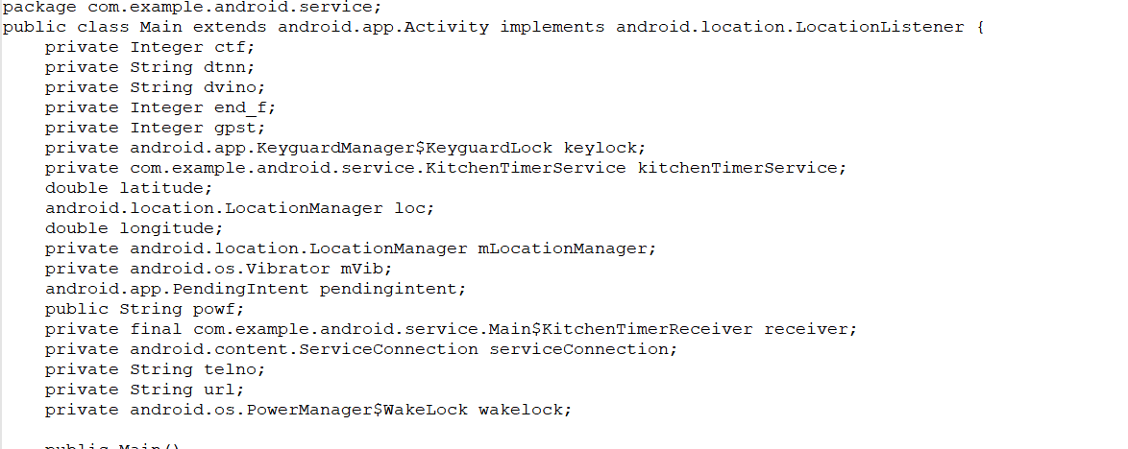

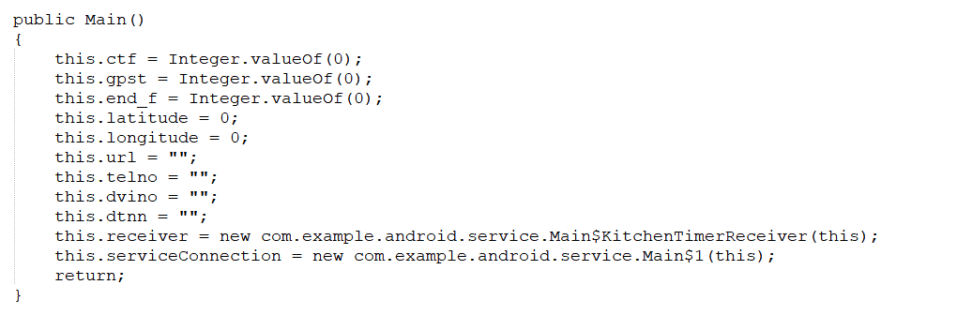

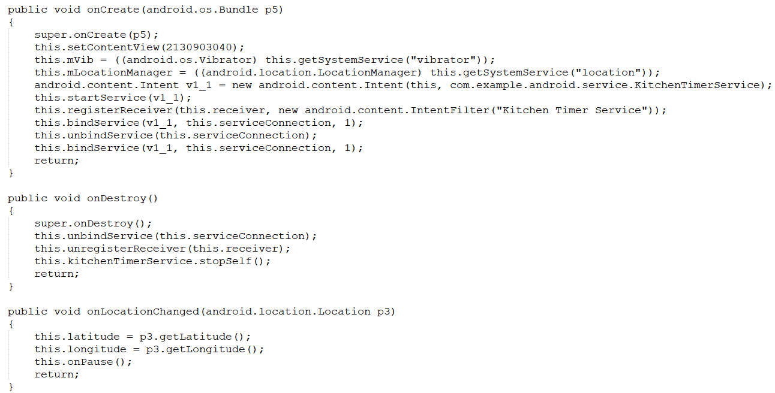

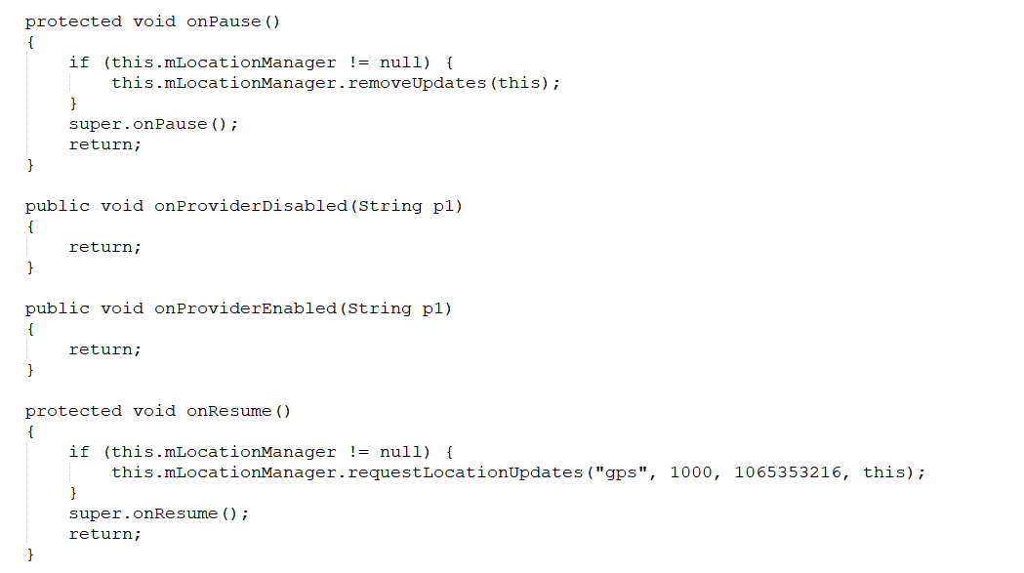

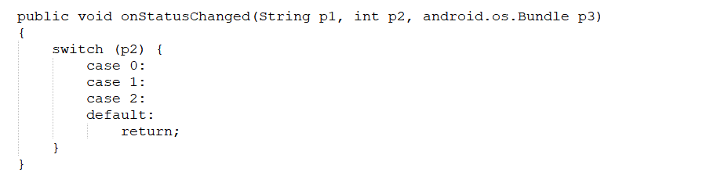

**Corresponding to the key code in this app：**

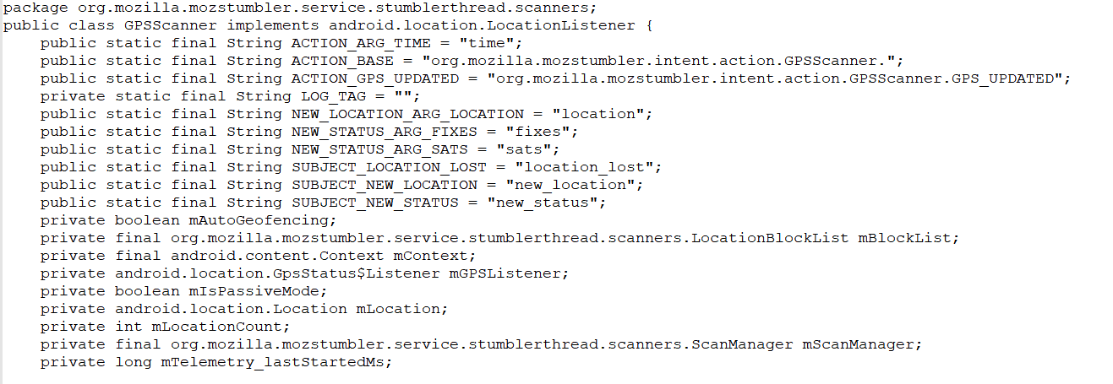

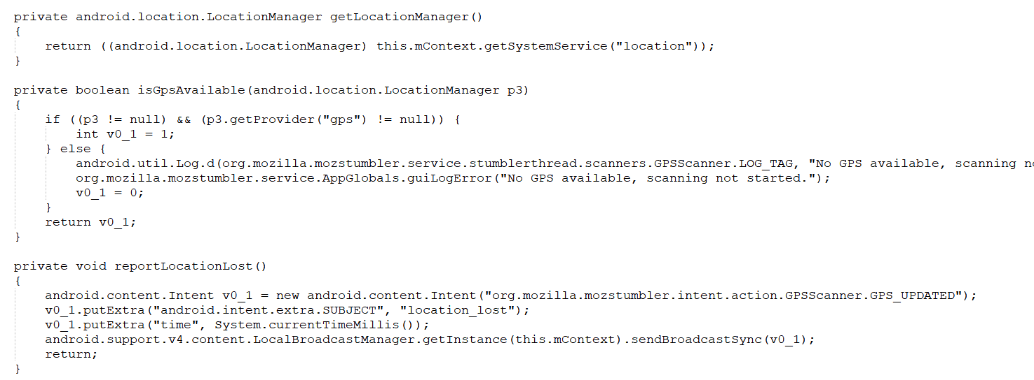

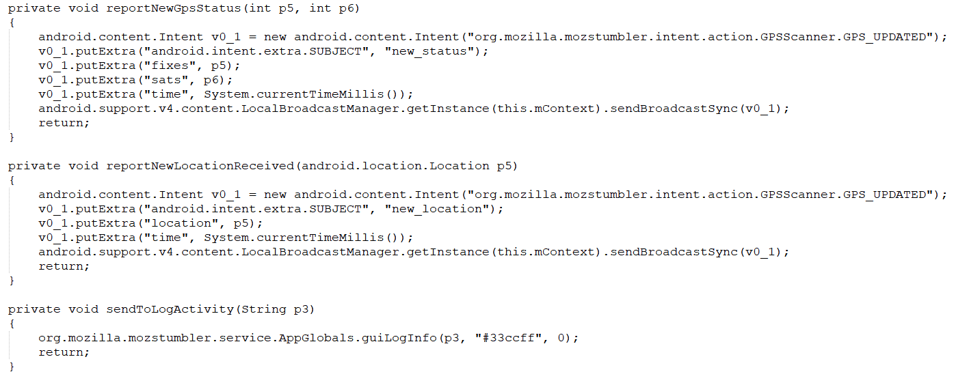

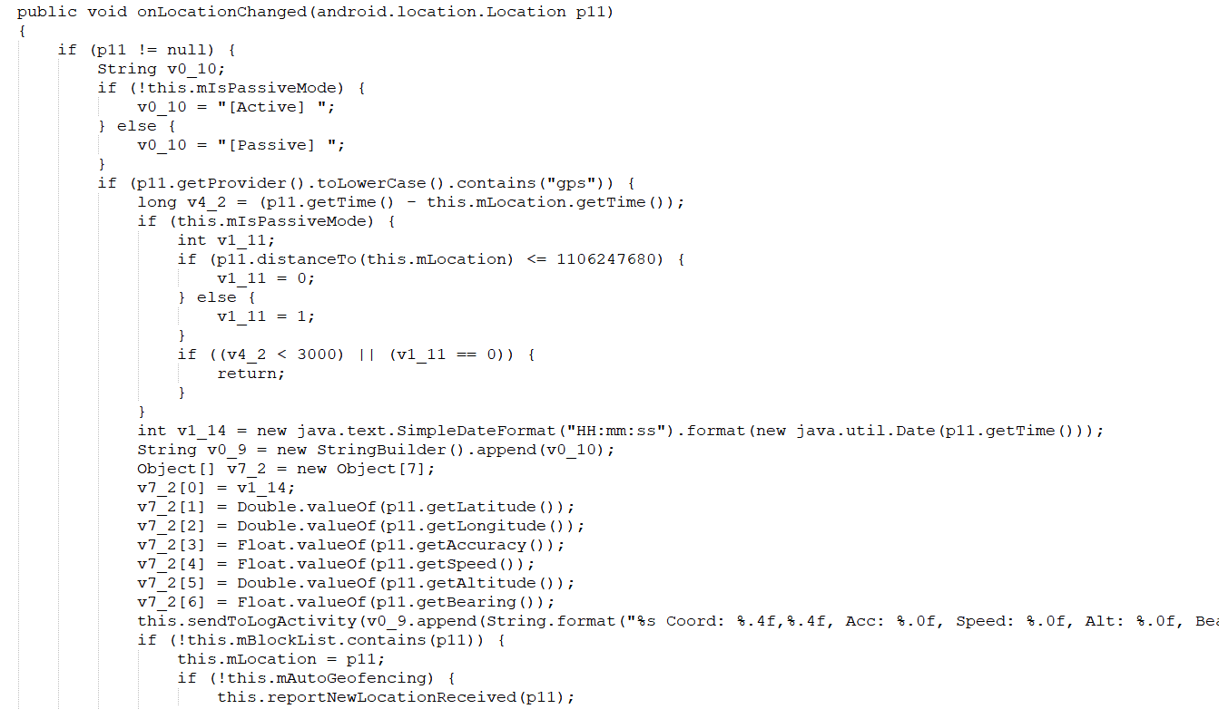

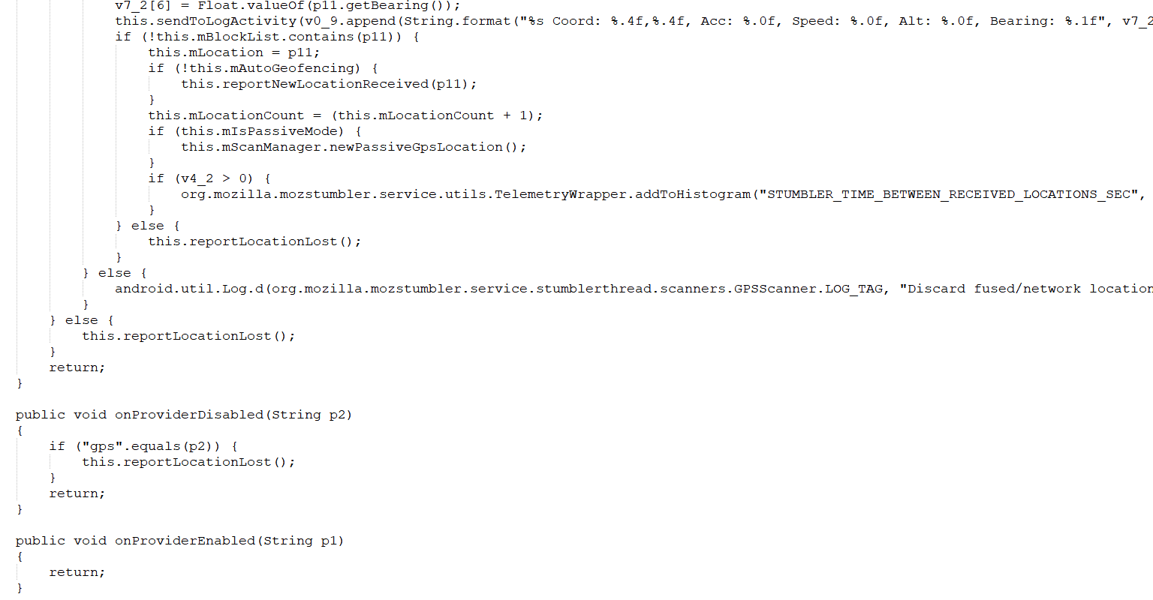

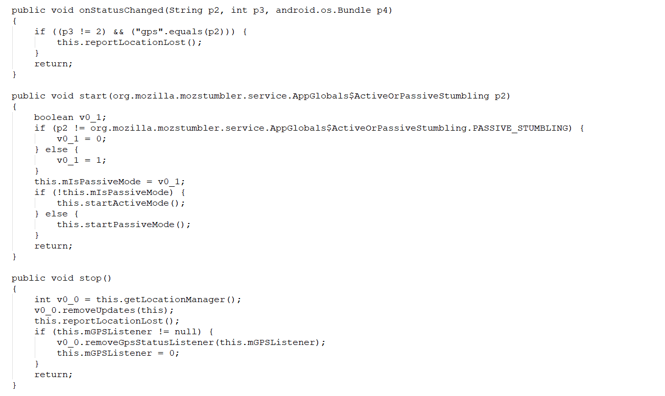

**For functions:：**

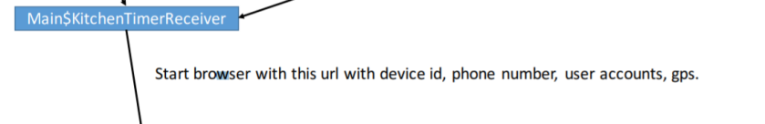

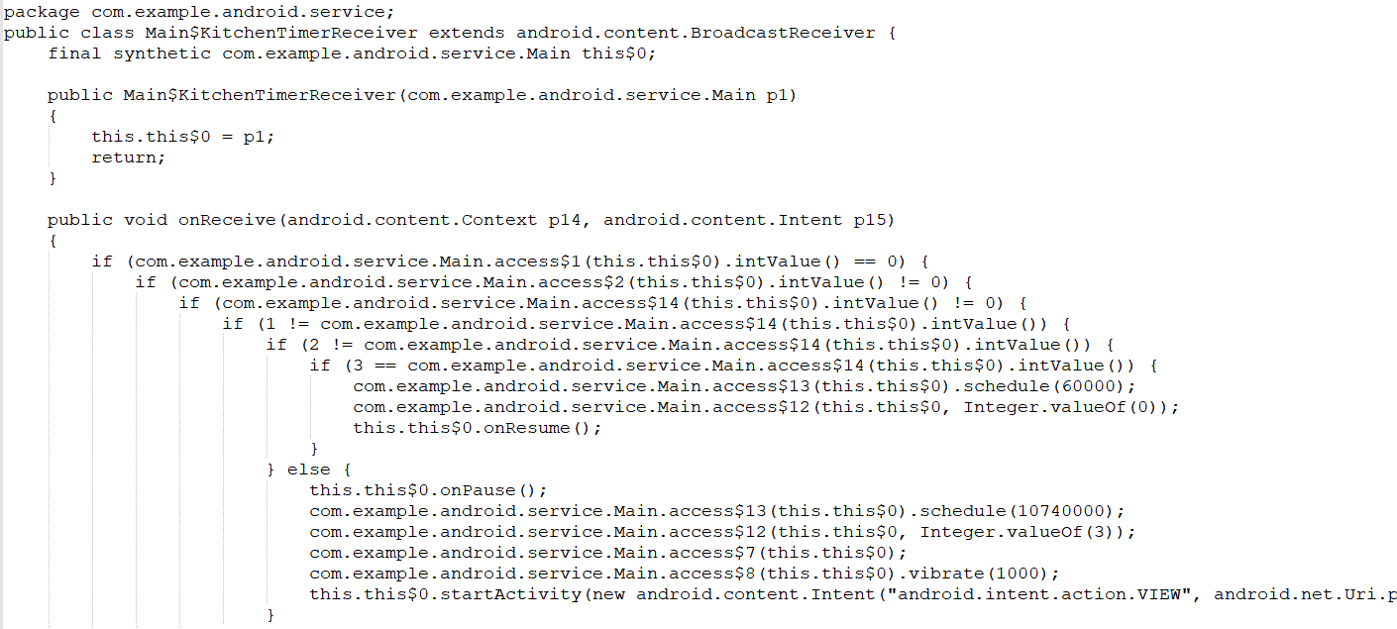

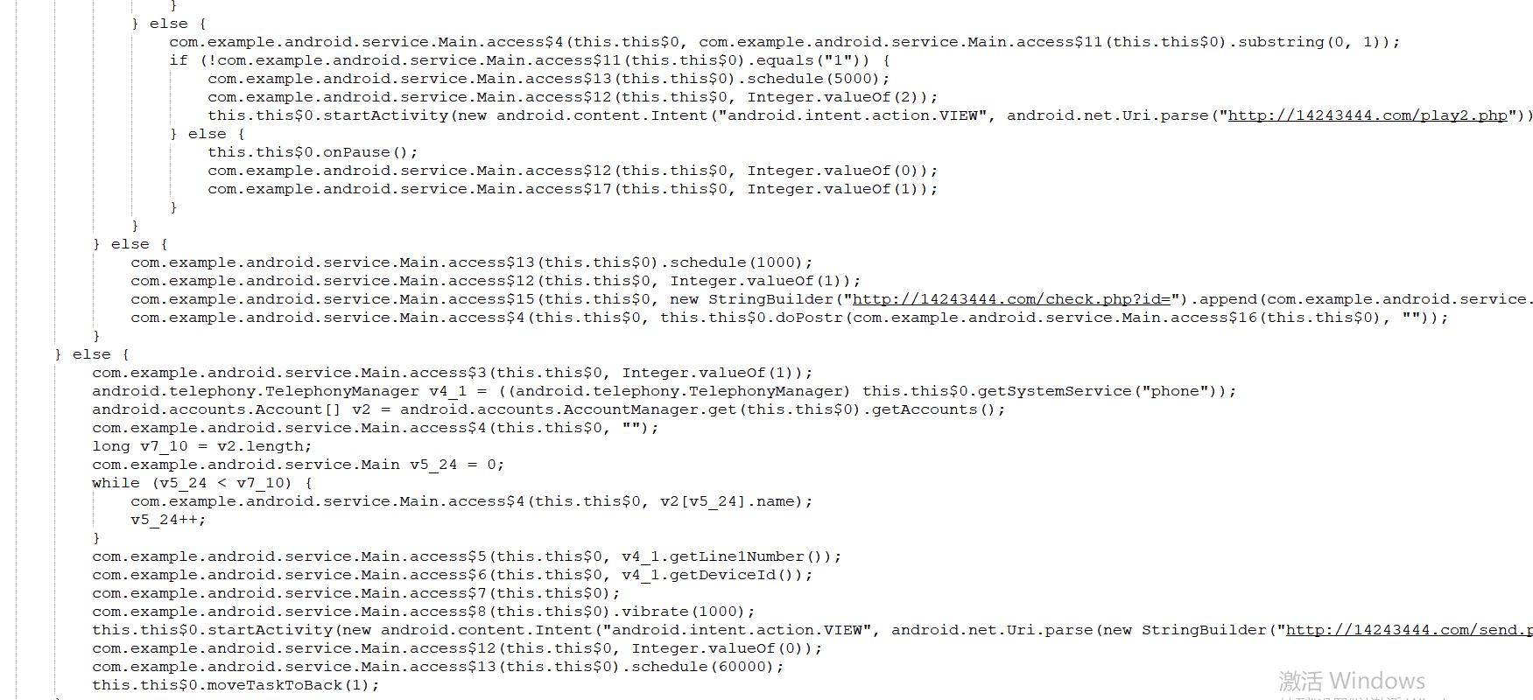

**Corresponds to the key code in this App: (for this part of the function app, only the key token matches, but not the function matches completely)**

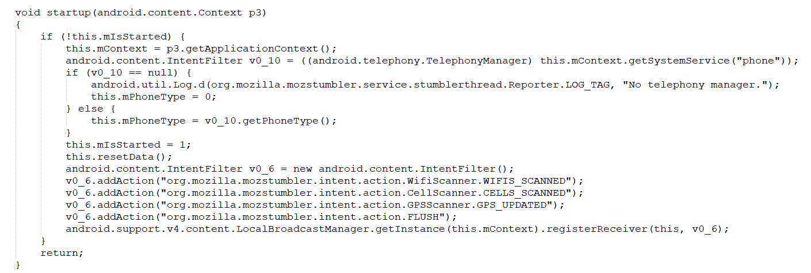

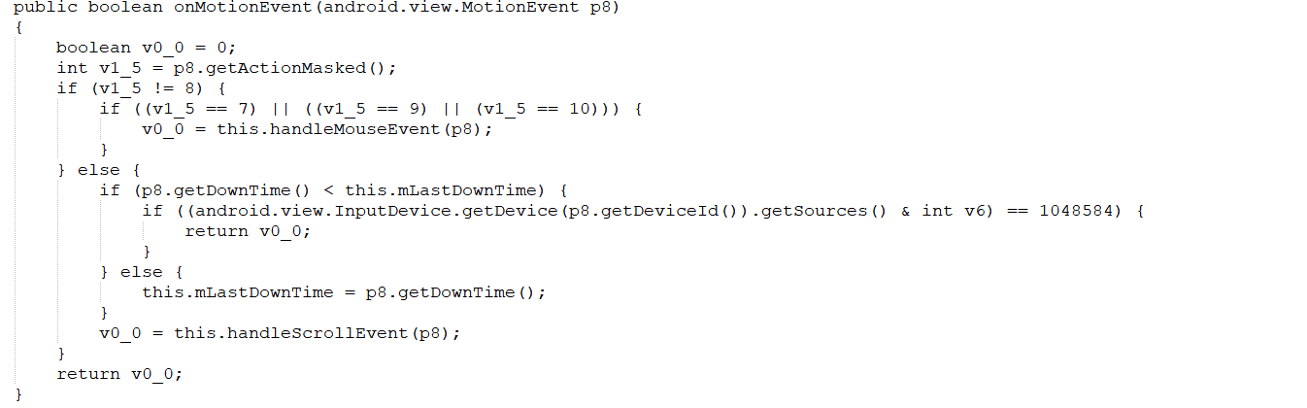

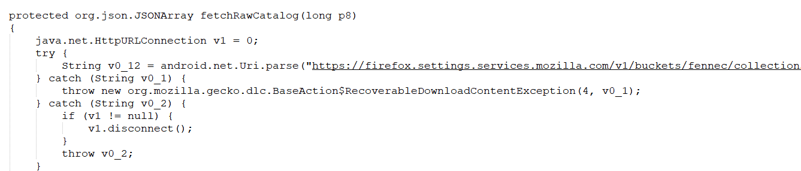

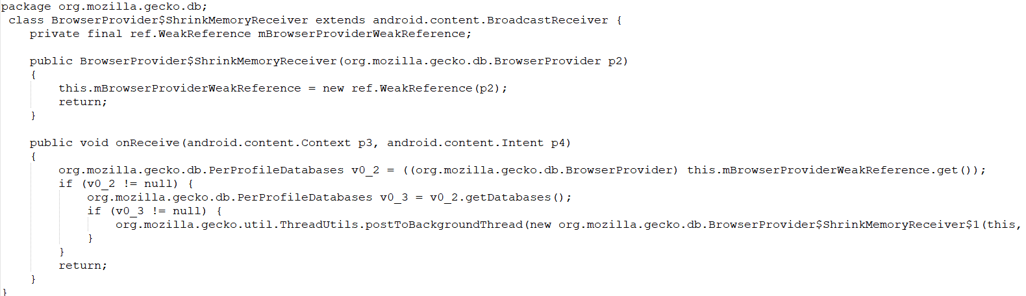

**For functions：**

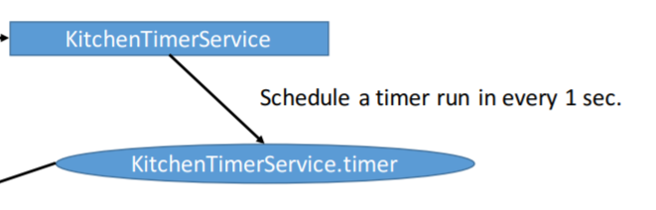

**The key code in sample is:**

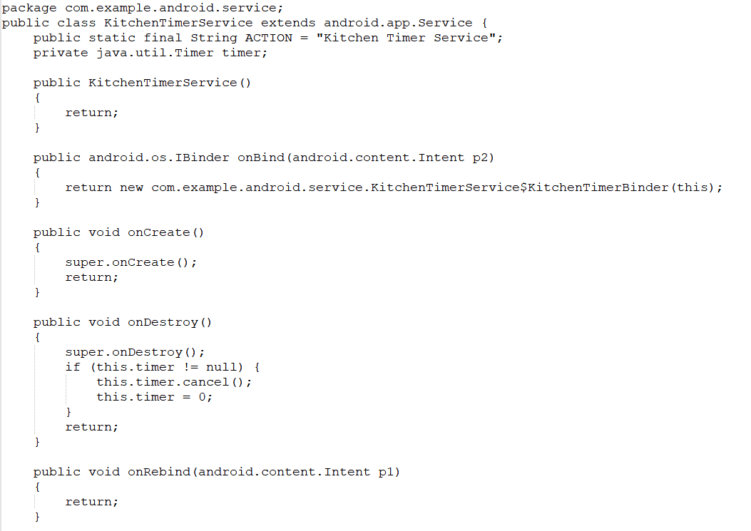

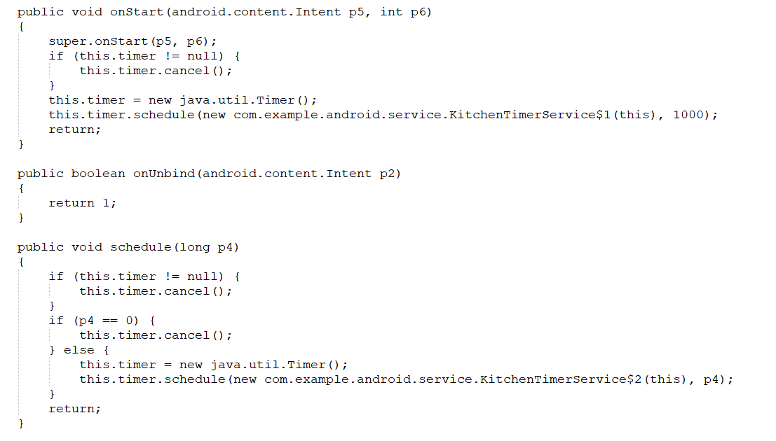

**Corresponding to the key code in this app：**

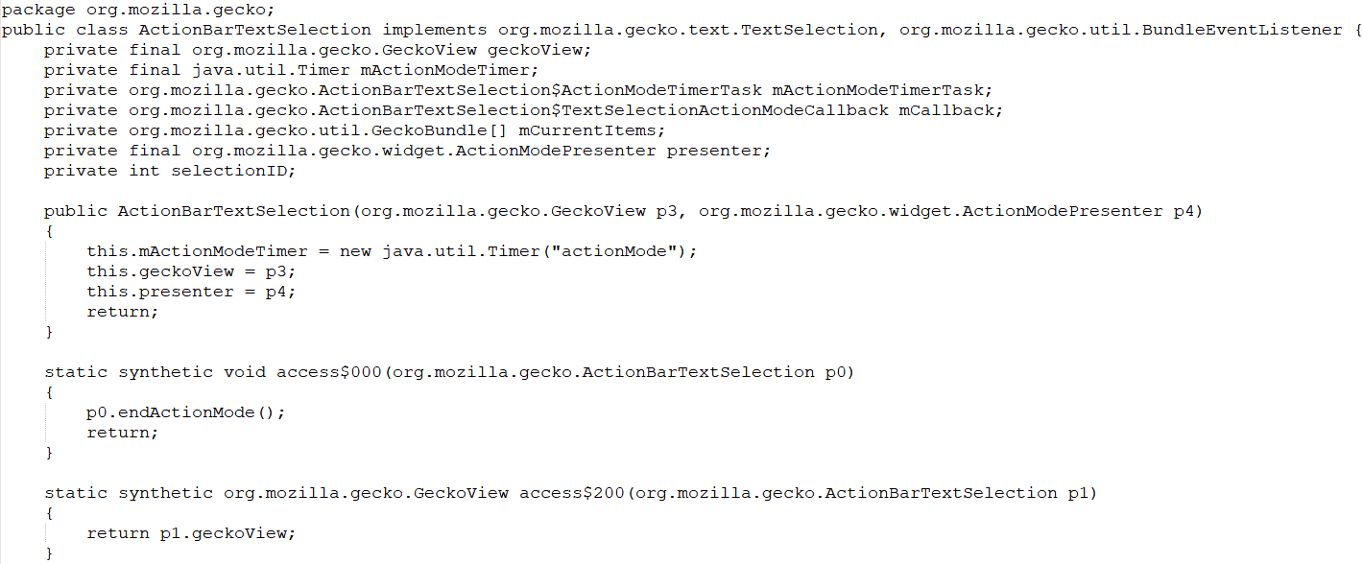

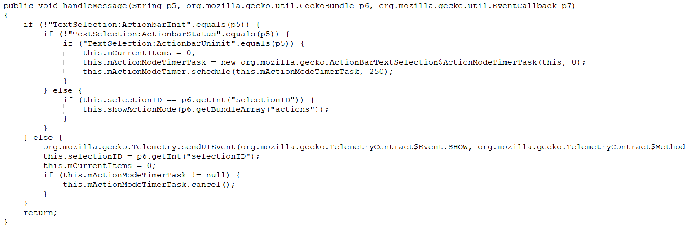

**Corresponding to the callback function in sample:**

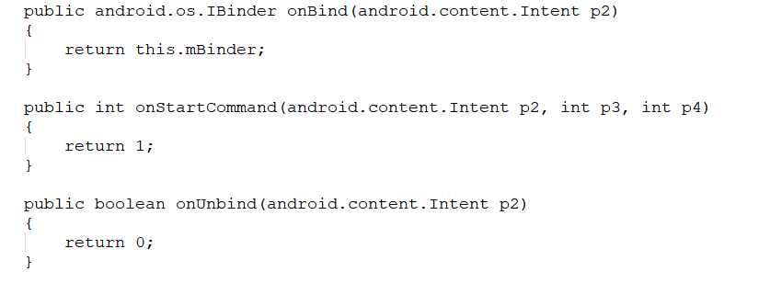



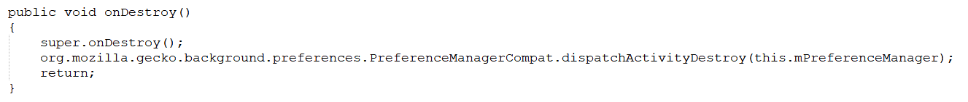

**Error Cause Analysis:**

**Because the GPS and personal information acquired in sample are sent to a fixed URL address through the network, while the GPS information and device information acquired in app are not used to send to a fixed URL address. Although the hierarchical and non-hierarchical token are matched, the ultimate purpose is different and there is no malicious behavior, so the recognition fails.**